S_ALR_87013182 -

Functionality

This report is useful in the analysis of materials with regard to prices (for example, comparison of the standard price and the periodic unit price) or inventory values (analysis of the price and exchange rate differences of the ending inventory).

Scenario
Can be used to analyze a material.You can select the currency/valuation used.
In the selection screen of the report, you can save the list of prices and inventory values as an extract so that you can access it later.

Requirements
Material ledger has been activated.

Menu Path | SAP menu → Accounting → Controlling → Product Cost Controlling → Actual Costing/Material Ledger → Information System → Detailed Reports → S_ALR_87013182 - Transaction History for Material
Transaction Code | S_ALR_87013182

1. Double Click on S_ALR_87013182 - Transaction History for Material.

Transaction History for a Material

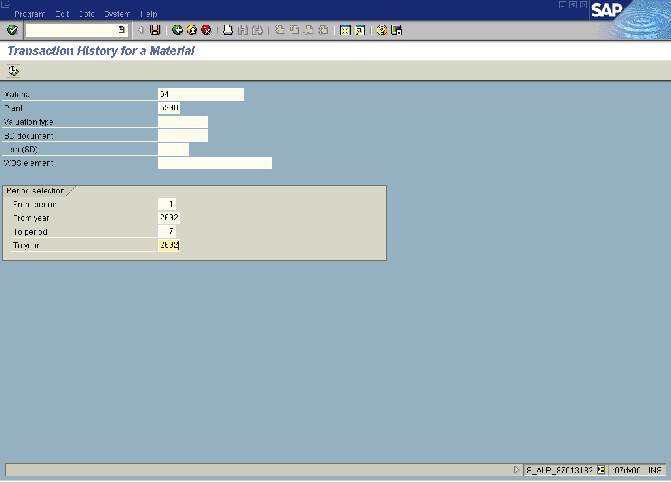

2. Update the following fields:

Field Name | Field Description | Values
Material | Code identifying a product or component | Example: 64
Plant | Code identifying the operational unit of the company where the material is manufactured and stored | Example: 5200
From period | Beginning period of analysis | Example: 01
From year | Beginning year of analysis | Example: 2002
To period | Ending period of analysis | Example: 07
To year | Ending year of analysis | Example: 2002

3. Click .

Transaction History for a Material

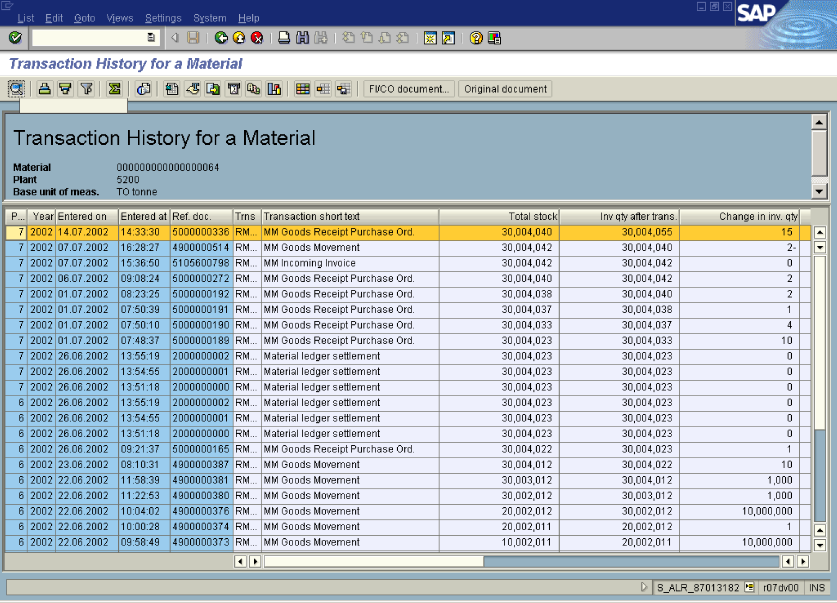

4. Mark the line by single click.

5. Click .

Details

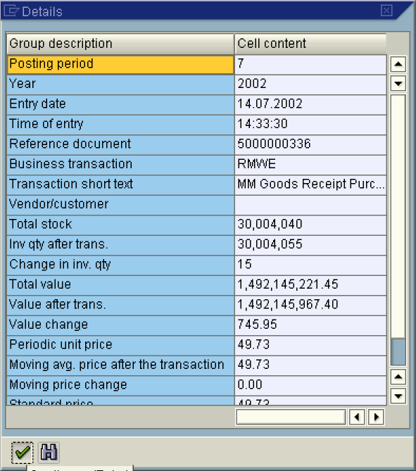
6. Click .

Transaction History for a Material

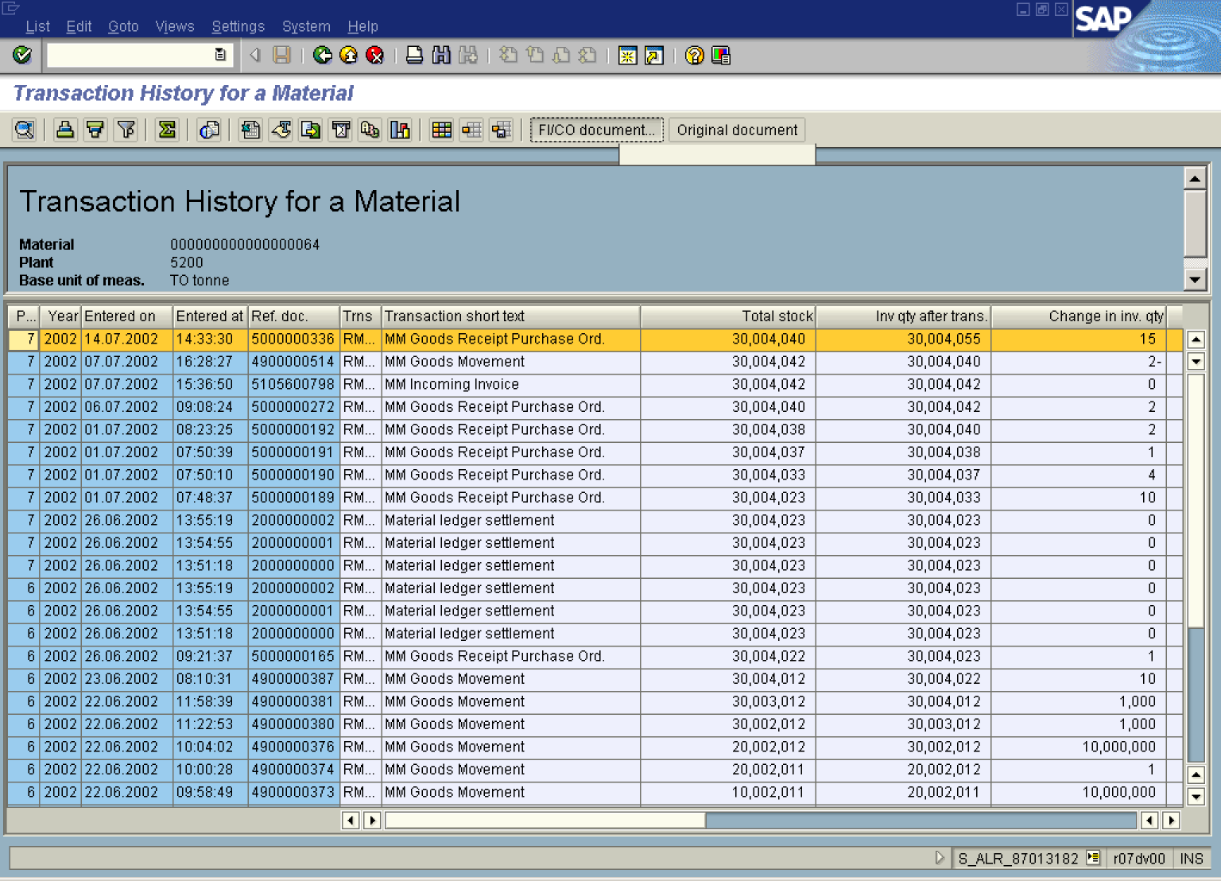
7. Click FI/CO document... Button .

List of Documents in Accounting

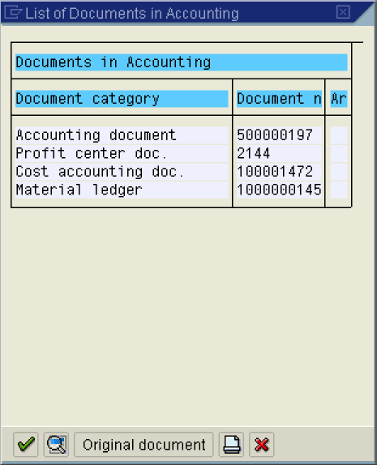
8. Click 1000000145 .

Display Material Ledger Document 1000000145: Overview

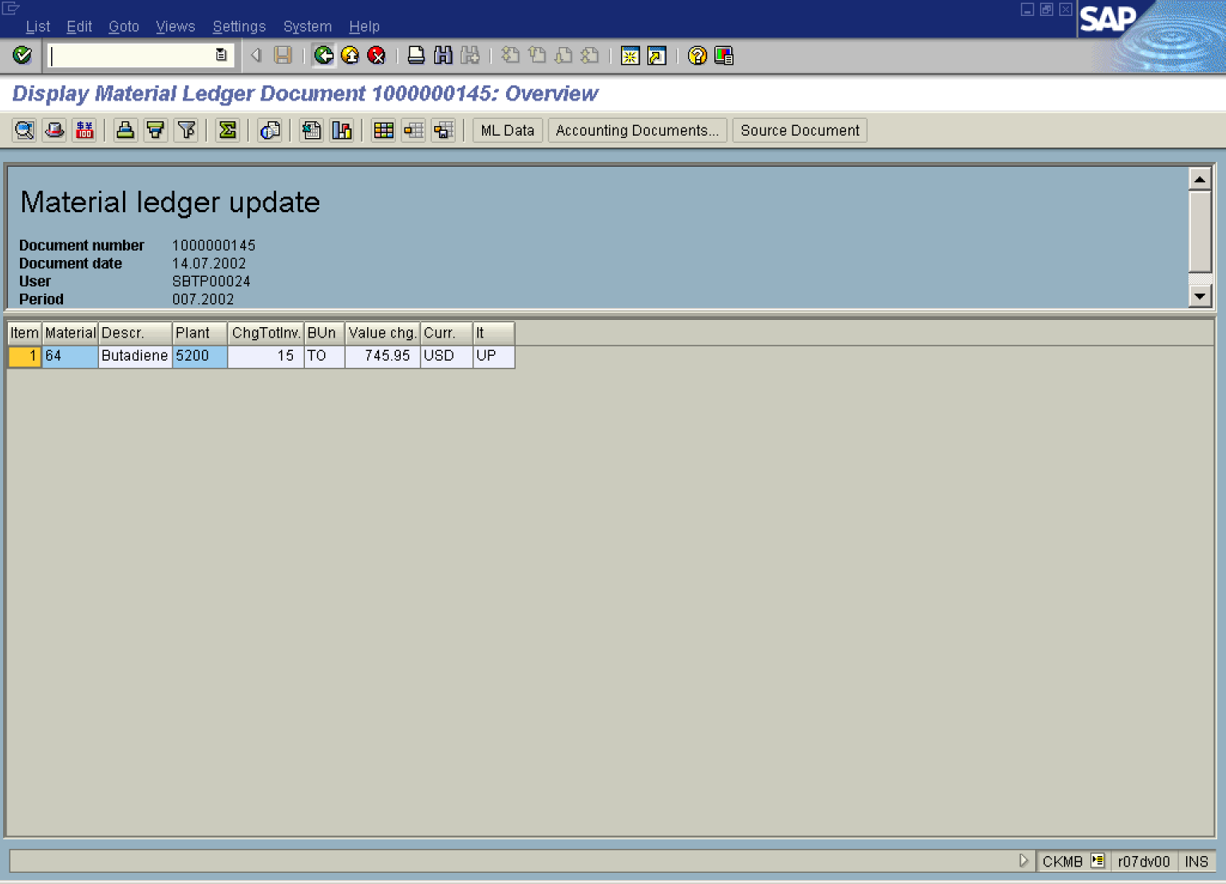
9. Click Back .
List of Documents in Accounting

10. Click 500000197 Button 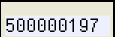.
Display Document: Overview

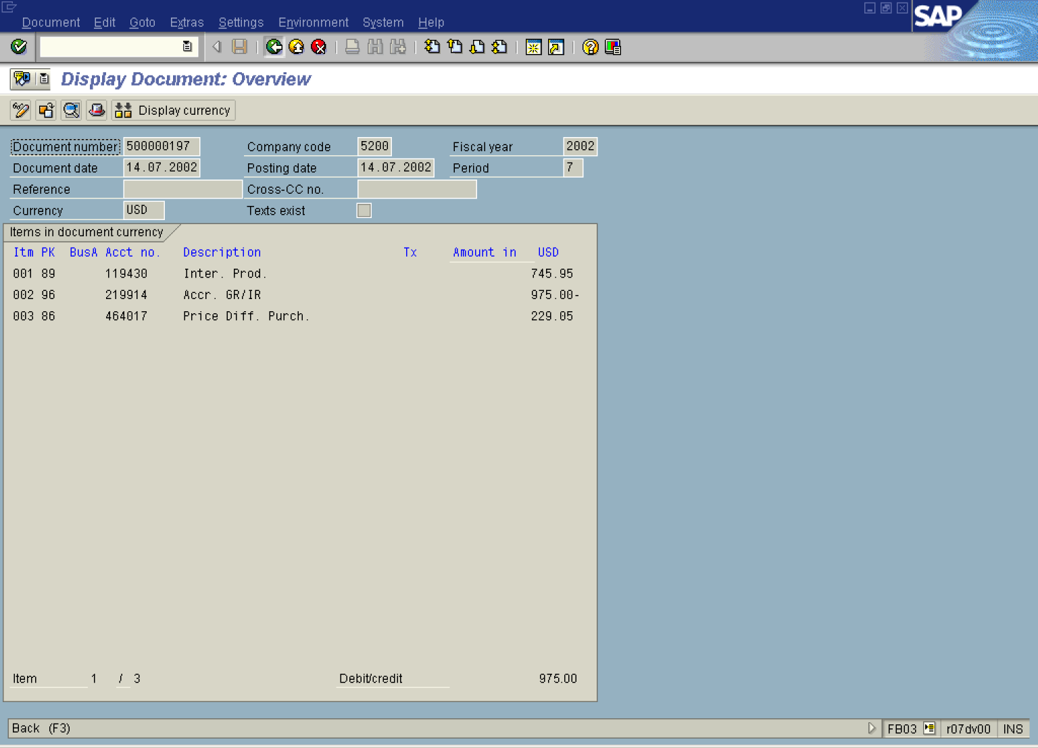
11. Click Back .

List of Documents in Accounting

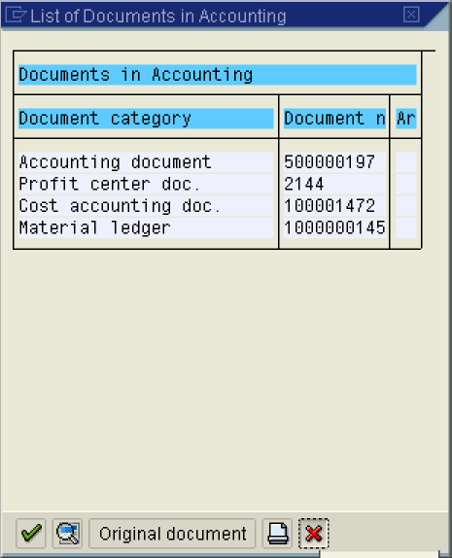

12. Click Cancel button.

Transaction History for a Material

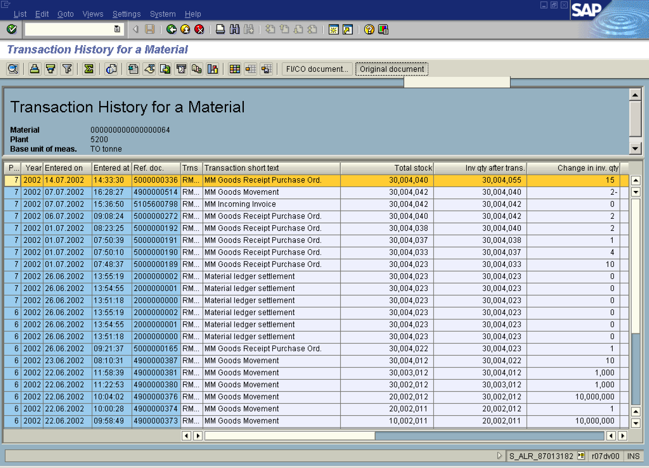

13. Click Original document Button .

14. Click Back .

Transaction History for a Material

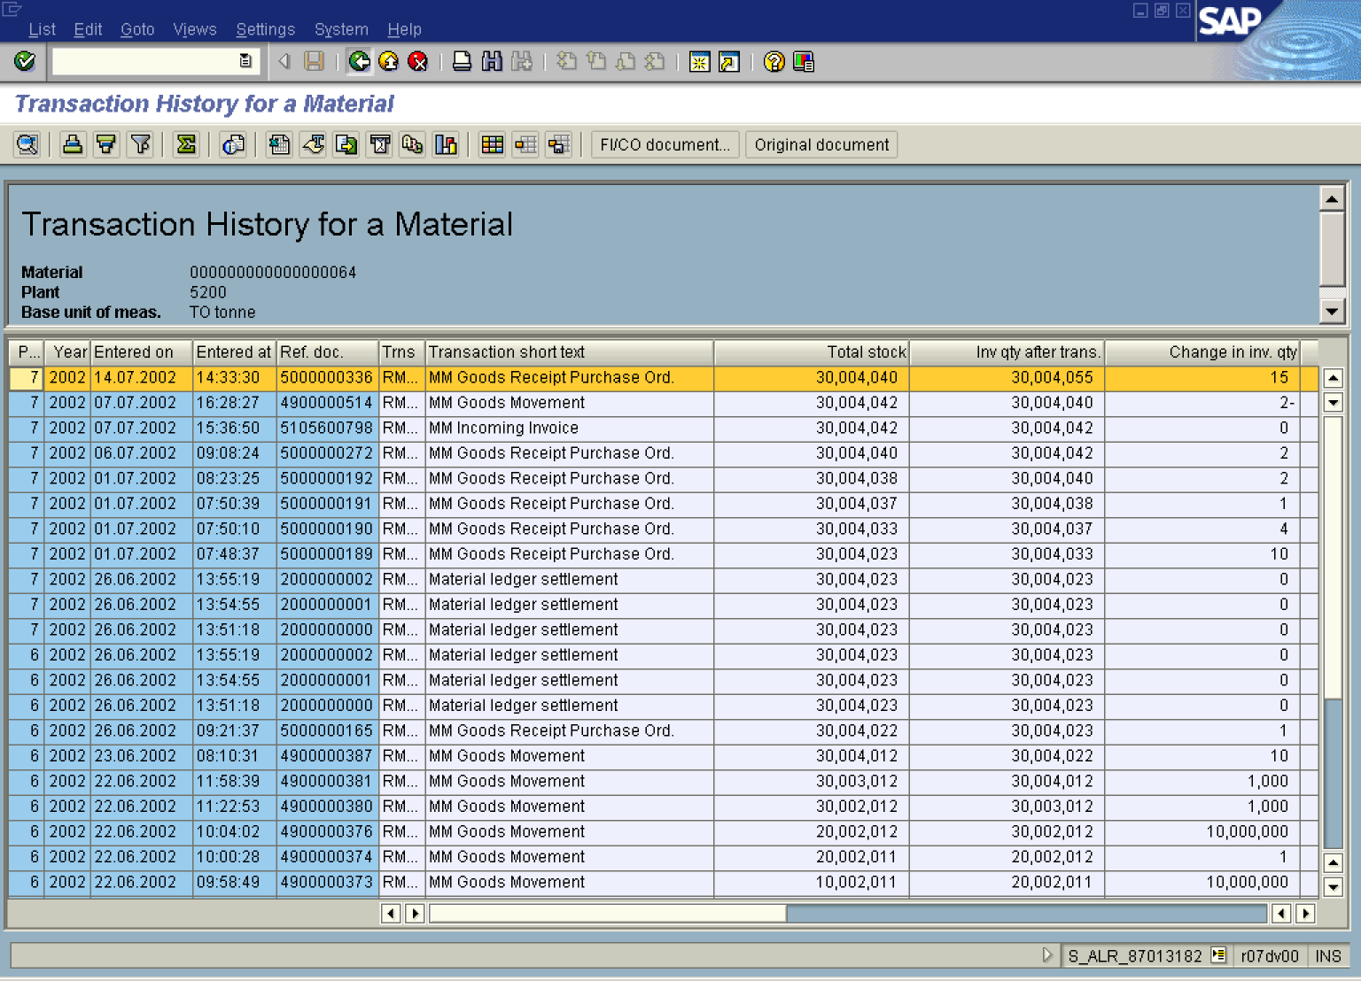

15. Click Back .

Exit list

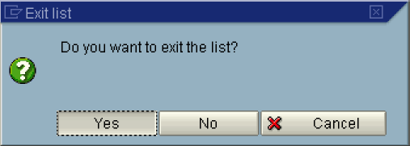

16. Click Yes Button .

